Four Corners: Sourcing in History Class
Analyzing Bias in Primary Sources

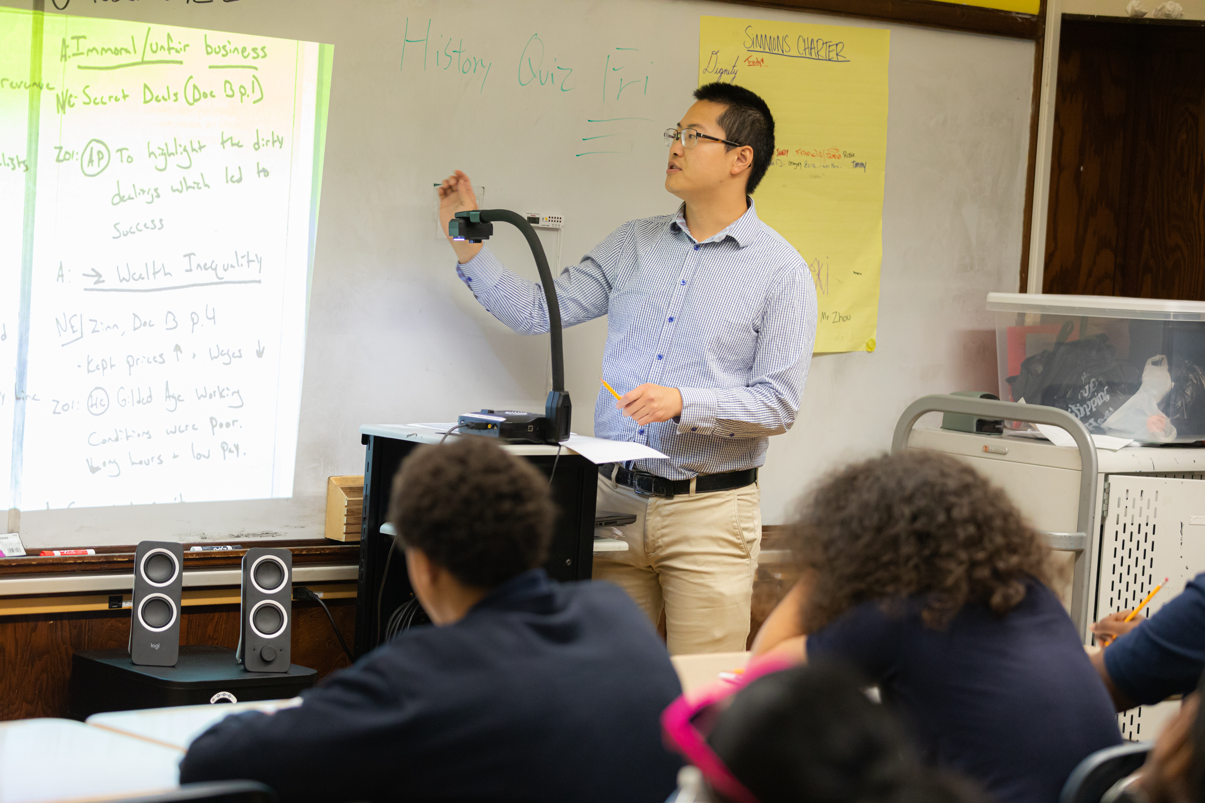
Rebecca Lord Gomez
Director of Education & Recreation
Mashantucket Pequot Tribal Nation
rgomez@mptn-nsn.gov

Fall 2023

Session Objectives:
- Describe the keys to exemplary Four Corners annotations
- Practice completing Four Corners annotations on primary source documents
- Participate in discourse centered on sourcing

See It: Four Corners
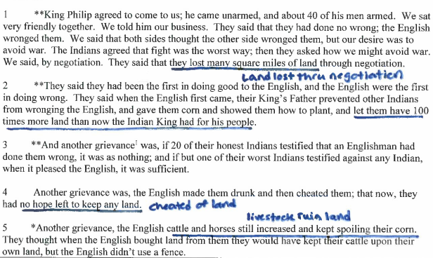
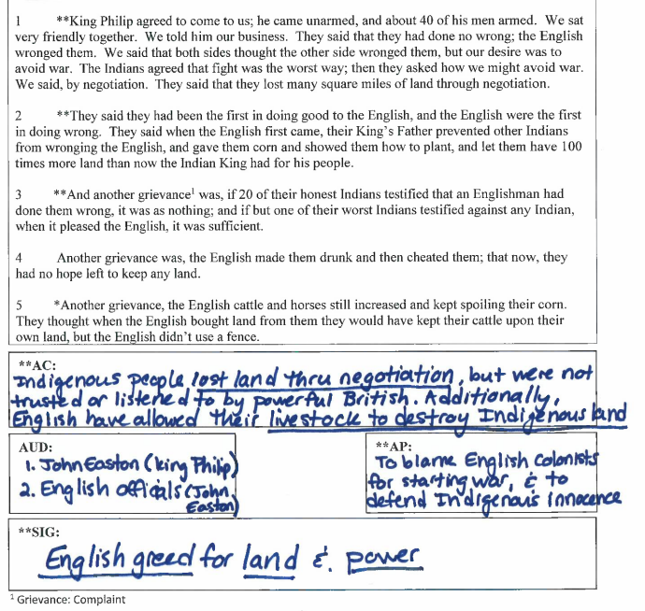
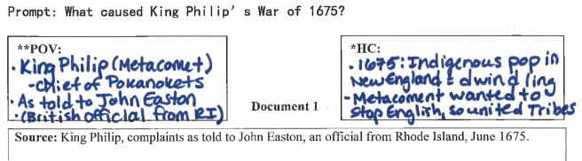

- What are the keys to exemplary Four Corners annotations?

- How will Four Corners annotations influence the strength of discourse and writing?

Name It: Four Corners
Annotation | Notes
POV
HC
AUD
AC
AP
SIG

Do It: Four Corners
What the Textbooks Say:
Directions: Actively read the textbook excerpt below and answer the question that follows.
Source: Independent Hall Association, ushistory.org, 2008.
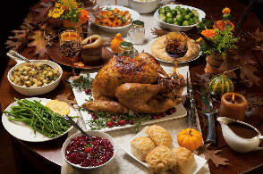
1 As was the custom in England, the Pilgrims celebrated their harvest with a festival. The 50 remaining colonists and roughly 90 Wampanoag tribesmen attended the “First Thanksgiving.”

2 **By early 1621, the Pilgrims had built crude huts on the shores of Plymouth Bay. Soon neighboring Indians began to build relations with the Pilgrims. Squanto, a local Indian who had been kidnapped and taken to England nearly a decade before, served as an interpreter with the local tribes. Squanto taught the Pilgrims to fertilize the soil with dried fish remains to produce a stellar corn crop.

3 *Massasoit, the chief of the nearby Wampanoags, signed a treaty of alliance with the Pilgrims in the summer. In exchange for assistance with defense against the feared Narragansett tribe, Massasoit supplemented the food supply of the Pilgrims for the first few years.

4 **By autumn of 1621, the Pilgrims had much for which to be thankful. After the harvest, Massasoit and about ninety other Indians joined the Pilgrims for the great English tradition of Harvest Festival. The participants celebrated for several days, dining on venison, goose, duck, turkey, fish and of course cornbread, the result of a bountiful corn harvest. This tradition was repeated at harvest time in the following years.

**Author’s Claim:

Today’s Inquiry:
Directions: Actively read the prompt and determine the historical thinking skills you’ll need to answer it.

Prompt: What really happened at the first Thanksgiving feast in 1621?

Historical Thinking Skill | Outside Evidence

Document Analysis:
Directions: Read the primary sources using Four Corner annotations, author’s claim and a SIG statement.

Prompt: What really happened at the first Thanksgiving feast in 1621?
**POV
*HC:

Document 1

Source: Edward Winslow, “A Relation or Journal of the Beginning and Proceedings of the English Plantation Settled at Plymouth in New England,” Mourt’s Relation, published in London, 1621.

Context: This text is the earliest known account of the events in Plymouth Plantation in Massachusetts. Edward Winslow was a Separatist who left England on the Mayflower and settled in Plymouth. He became a senior leader of the Pilgrims and was relied upon by William Bradford, the governor of the colony.

After we brought in our harvest, our governor sent four men out to hunt [big birds], so that we might rejoice together. They killed four in one day. After we had gathered the fruits of our labors, we served the Company almost a week, at which time amongst other recreations, we [practiced using our weapons]. Many of the Indians came among us and their greatest King Massasoit came with some ninety men, whom for three days we entertained and feasted. They went out and killed five Deer, which they brought to the Plantation and [gave to] our Governor, and upon the Captain and others. And although it be not always so plentiful, as it was at this time with us, we are so far from want, that we [were happy to share food with the Indians].

**AC:

AP:
**AUD:

**SIG:

**To what extent does Document 1 corroborate (support) the textbook argument? Explain your thinking.
________________________________________________________________________________________________________________________________________________________________________________________________________________________________________________________________________________________________________________________________________________________________________________________________________
Prompt: What really happened at the first Thanksgiving feast in 1621?
**POV
**HC:

Document 2

Source: Ramona Peters, member of the Mashpee Wampanoag Tribe and the nation’s Historic Preservation Officer, article in Indian Country Today, 2017.

Context: The Wampanoag were the Indigenous peoples living in the area of Massachusetts where the Pilgrims arrived. They were the Indigenous nation involved in the First Thanksgiving.

1 The leader of our nation at the time—Yellow Feather Oasmeequin (Indigenous name for Massasoit)—made a treaty with John Carver, the first governor of the colony. It said we’d let them be there and we would protect them against any enemies, and they would protect us from any of ours.

2 **This was also the Pilgrims’ first successful harvest and they were celebrating in a day of their own thanksgiving. And so they started celebrating by shooting guns in the air. They were shooting guns and cannons as a celebration, which alerted us because we didn’t’ know who they were shooting at. So Massasoit gathered up some 90 warriors and showed up at Plymouth prepared to engage in case they were taking any of our people It was a fact-finding mission. When they arrived it was explained through a translator that they were celebrating the harvest, so we decided to stay and make sure that was true. During those few days, the men went out to hunt and gather food—deer, ducks, geese and fish.

3 **In those days, the English really needed to rely on us and, yes, they were polite as best they could be, but they regarded us as savages nonetheless.

**AC:

AP:
**AUD:

**SIG:

**To what extent does Document 2 corroborate the textbook and Document 2? Explain your thinking.
______________________________________________________________________________________________________________________________________________________________________________________________________________________________________________________________________________________________________
Prompt: What really happened at the first Thanksgiving feast in 1621?
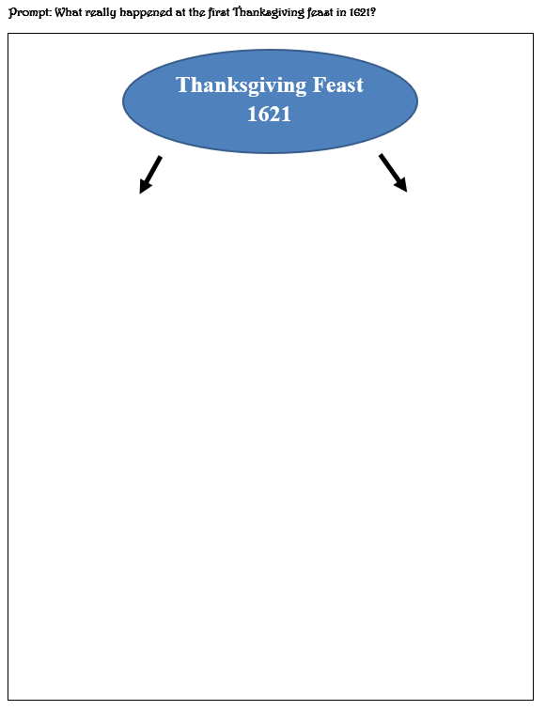
Historical Writing:
Directions: Answer today’s prompt, using the rubric to help you. Then provide two pieces of paraphrased and cited evidence to support your argument.

Prompt: What really happened at the first Thanksgiving feast in 1621?

**Argument:
____________________________________________________________________________________________________________________________________________________________________________________________________________________________________________________________________________________________________________________________________________________________________________________________________________________________________________________________________________________________________________________________________________________________________________________________________________________________________________________________________________________________________________________________________________________________________________________________________________________________________________________________________________________________________________________________________________________________________________________________________________________
Thesis Statement | Introduction Paragraph |  | ______/2
DTH. Thesis Statement | States an argument that directly addresses all parts of the question (takes a position on what really happened at the first Thanksgiving). Addresses both sides of the argument. The thesis must do more than restate the question and should include two specific sub-arguments, which 1 point awarded per sub-argument.
DTH. Thesis Statement | Sub-Argument 1 | Sub-Argument 2

Paraphrased & Cited Evidence: Put the evidence in your own words and cite the document #.

Evidence #1 | Evidence #2
**

Document Use | Evidence (N/E) |  | ______/2
DDU. Document Use | Utilizes the content of both documents to support the stated thesis or a relevant argument. Must be paraphrased and cited. Paraphrase should be of a specific line (or identification of a specific detail in the image), not a general summary of the document. One point per piece of evidence.
DDU. Document Use | D1 | D2
Core Idea

Final Reflection
- How do the Four Corners help students to focus on sourcing?

- How does the Four Corners annotation method help to support all learners in accessing historical materials?

Wampanoag: An Indigenous nation on Cape Code in New England. In the 1600s, there were over 40,000 Wampanoag in more than 67 villages.

