Teaching the Pequot War
Finding the Most Productive Struggle

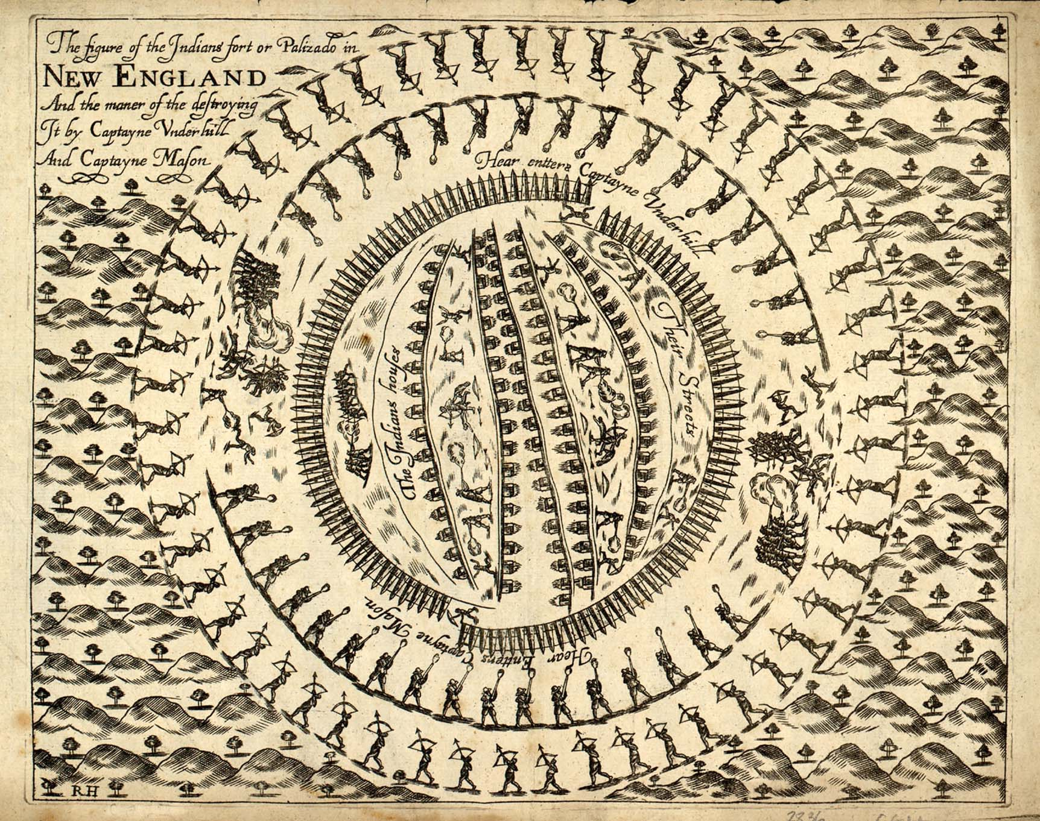
John Underhill, engraving from “Newes From America,” London, England, 1638.
Rebecca Lord Gomez
Director of Education & Recreation
Mashantucket Pequot Tribal Nation
rgomez@mptn-nsn.gov

Connecticut Council for the Social Studies
Annual Conference
Central Connecticut State University
Fall 2023

Session Objectives:
- Review Mashantucket Pequot Tribal Nation curriculum offered to Connecticut teachers
- Identify what lesson cycles and stages are
- Define “Most Productive Struggle” and determine “Most Productive Struggle” in a lesson
- Intellectually prep for an inquiry lesson by beginning to create a Monitoring Key
Opening Reflection
- What resources have you used to teach about the Pequot War in your classroom?

- How do you prepare to teach lessons grounded in student discourse?

The Arc of Teaching History
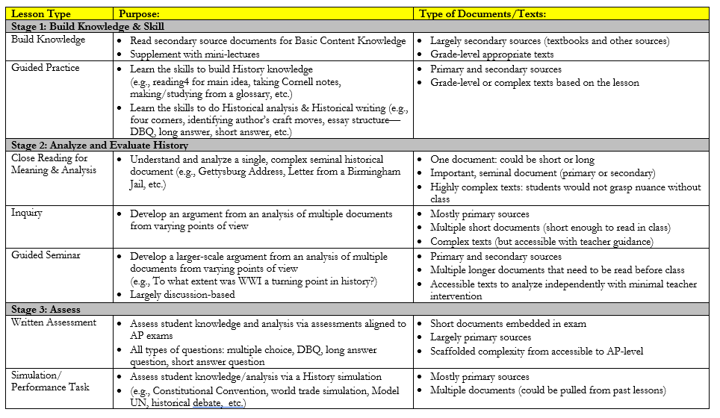
- What are the 3 stages of history instruction in the Pequot curriculum?

- How do these 3 stages help to build a layered understanding of Pequot history?

- What questions do you have about the 3 stages?



- What are the 4 steps of the lesson internalization process?

- Why does lesson internalization matter?

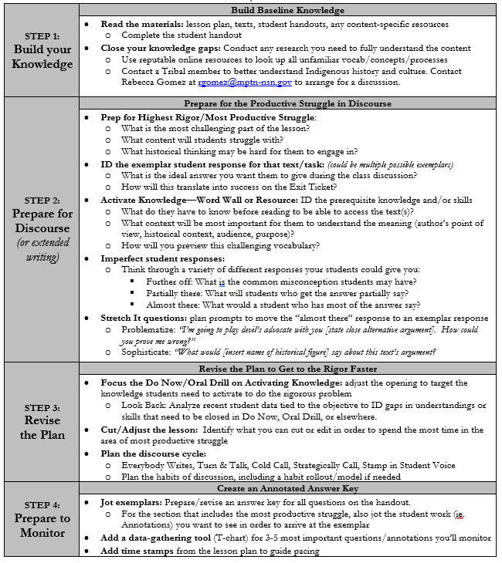
Lesson Internalization

Core Idea #1

The Most Productive Struggle
Notes:

- What is the most productive struggle in this lesson?

- What do you believe is the ideal student response to the most productive struggle?

Plan for the End Goal
- How did this teacher successfully prepare students to grapple with the most productive struggle?

- What else do you notice about this teacher’s intellectual prep?

Mrs. Marvania’s Handout:
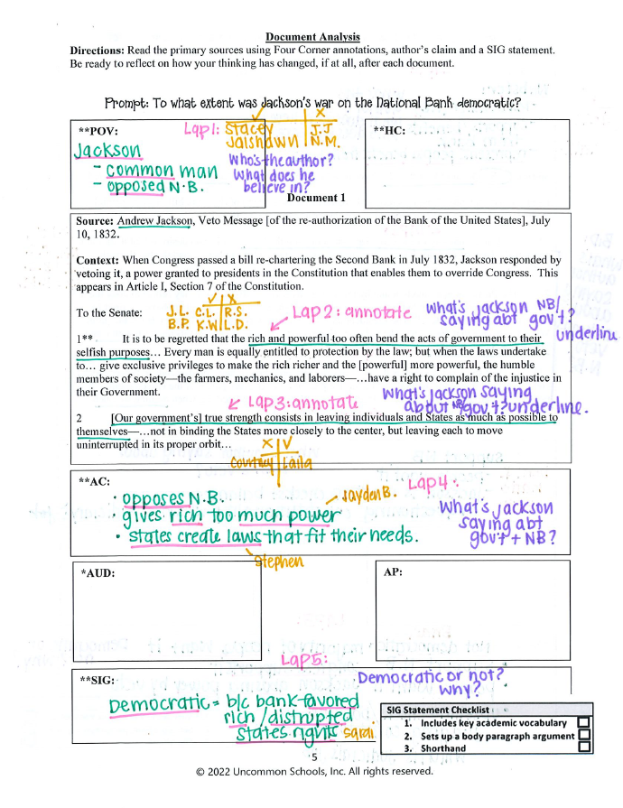
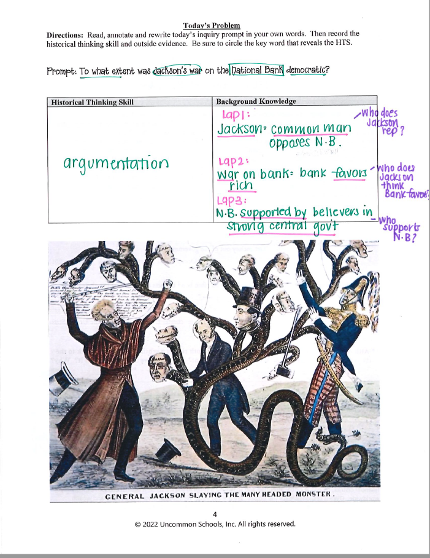

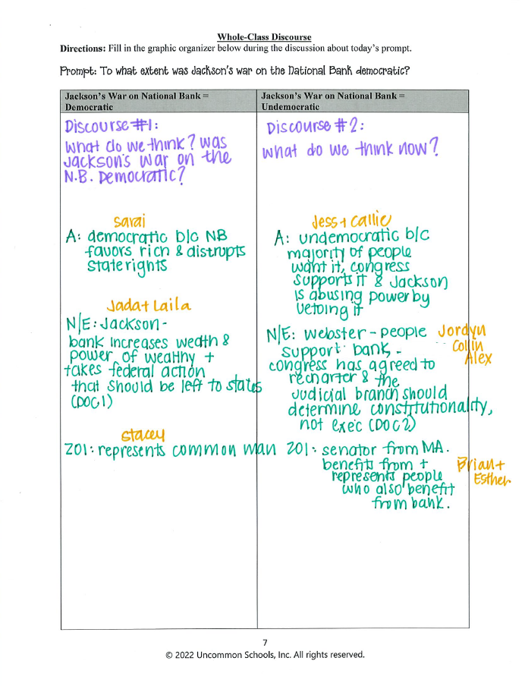
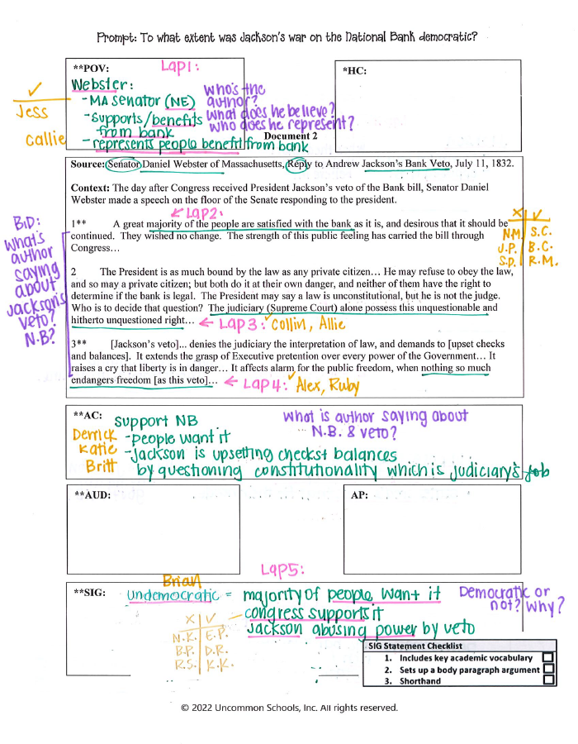

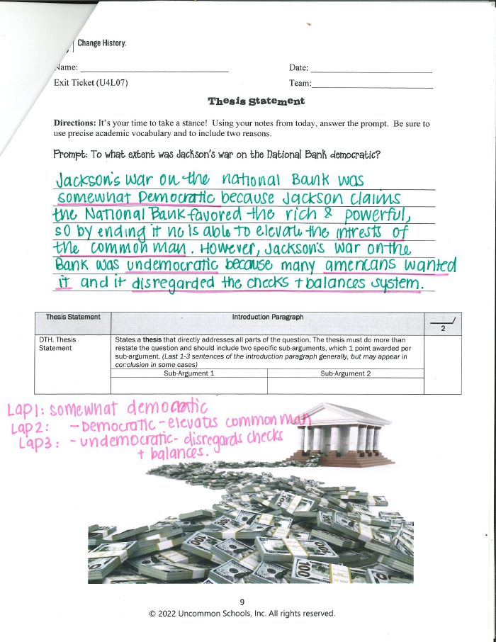
Core Idea #2

