Name: _________________________________ Date: ___________________________
Do Now
The Mystic Massacre
Directions: Analyze the engraving below and answer the questions that follow in complete sentences.

Source: The figure of the Indians' fort or palizado in New England and the manner of the destroying it by Captain Underhill and Captain Mason / RH. Connecticut, 1638.

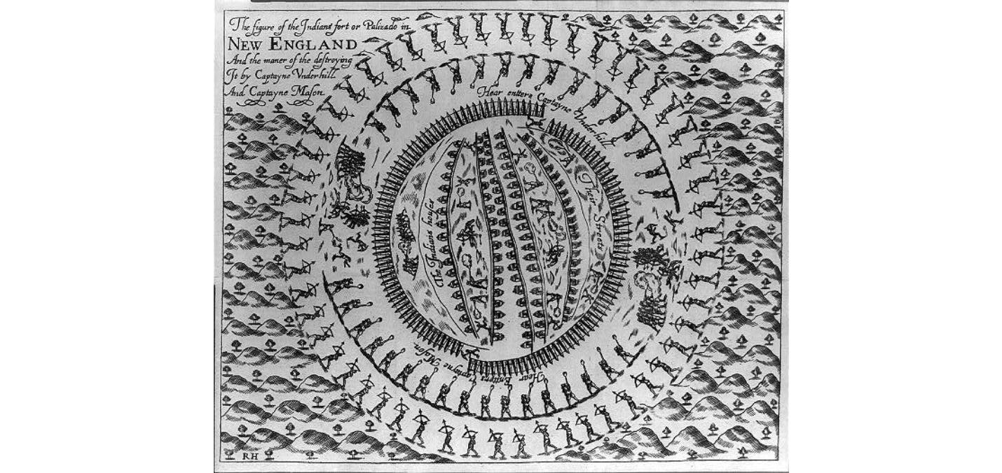
Context: The engraving pictured below recounts The Mystic massacre – also known as the Pequot massacre and the Battle of Mystic Fort – which took place on May 26, 1637 during the Pequot War, when a force from Connecticut Colony under Captain John Mason and his allies set fire to the Pequot Fort near the Mystic River. They shot anyone who tried to escape the wooden palisade fortress and killed most of the village. There were between 400 and 700 Pequots killed during the attack; the only Pequot survivors were warriors who were away in a raiding party with their sachem Sassacus.

- Who created this image and why? What are the clues?
____________________________________________________________________________________________________________________________________________________________________________________________________________________________________________________________________________________________________________________________________________________

- What story does the image tell about the Mystic Massacre? How was the Pequot Fort destroyed?
____________________________________________________________________________________________________________________________________________________________________________________________________________________________________________________________________________________________________________________________________________________

- Based on the image and context, who might be responsible for the Mystic Massacre?
____________________________________________________________________________________________________________________________________________________________________________________________________________________________________________________________________________________________________________________________________________________

- Is there anything interesting or surprising about the image and the story it tells? What questions does it raise?
____________________________________________________________________________________________________________________________________________________________________________________________________________________________________________________________________________________________________________________________________________________

Name: _________________________________ Date: ___________________________
Classwork
Close Reading, Day 1: Treaty of Hartford
Focus: The Pequot War, war was fought in 1636–37 by the Pequot people against a coalition of English settlers from the Massachusetts Bay, Connecticut, and Saybrook colonies and their Native American allies (including the Narragansett and Mohegan). It was an especially brutal war and the first sustained conflict between Native Americans and Europeans in northeastern North America. The war lasted 11 months and involved thousands of combatants who fought several battles over an area encompassing thousands of square miles. In the first six months of the war, the Pequot, with no firearms, won every engagement against the English. Both sides showed a high degree of sophistication, planning, and ingenuity in adjusting to conditions and enemy countermeasures. Indeed, the English suffered dozens of casualties in the early stages of the war before they were able to adapt their Old-World military experiences to the battlefields of the New World and win decisive engagements. In the end, the Treaty of Hartford, signed in 1638 by the English, Mohegan and Narragansett tribes, officially ended the Pequot War and forever changed the political and social landscape of southern New England, and it influenced colonial and U.S. policies toward Native Americans for centuries. The massacre of the Pequot at Mystic demonstrated to all observers, in southern New England and elsewhere, the English ability and will to wage total war against their Indian enemies. Who benefitted from this treaty and who ultimately would suffer the immense burden of this destructive war? What did the Treaty of Hartford actually do and how did it impact the Pequot people?

Today’s Problem
Directions: Read, annotate and rewrite today’s inquiry prompt in your own words. Then record the historical thinking skill and outside evidence. Be sure to circle the key word that reveals the Historical Thinking Skill.

Prompt: How did the Pequot War impact the Pequot people?

Historical Thinking Skill | Background Knowledge

Close Reading
Directions: Begin by sourcing today’s document for Author’s Point of View, Historical Context and Intended Audience. Then closely read the text for the central idea of the congressional action.

Prompt: How did the Pequot War impact the Pequot people?
Author’s Point of View
Historical Context:

Source: Articles of agreement between the Colony of Connecticut and the Indian sachems, Dated 1638.

Context: The Treaty of Hartford was a treaty between New England, the Mohegan and the Narragansett on September 21, 1638, in Hartford, Connecticut that officially ended the Pequot war. The Treaty would reshape the region of New England and have lasting impacts on the Pequot people, European colonists, and other tribes in the region.

Treaty of Hartford
Articles of Agreement between the English in Connecticut and the Indian Sachems

A covenant and agreement made between the English inhabiting the jurisdiction of the River of Connecticut of the one part and Miantonomo, the Chief Sachem of the Narragansetts, in the behalf of himself and the other chief sachems there, and Poquiam or Uncas, the Chief Sachem of the Indians called the Mohegans, in the behalf of himself and the sachems under him, as followeth at Hartford, the 21st September 1638.

First, there is a peace and familiarity made between the said Miantonomo and the Narragansett Indians and the said Poquiam and Mohegan Indians and all former injuries and wrongs offered each to other remitted and buried and never to be renewed anymore from henceforth.

[Second,] it is agreed if there fall out injuries and wrongs for future to be done or committed each to other or their men, they shall not presently revenge it, but they are to appeal to the English, and they are to decide the same, and the determination of the English to stand, and they are each to do as is by the English set down, and if the one or the other refuse to do, it shall be lawful for the English to compel them and to side and take part if they see cause against the obstinate or refusing party.

[Third], it is agreed and a conclusion of peace and friendship made between the said Miantonomo and the said Narragansetts and the said Poquiam and said Mohegans as long as they carry themselves orderly and give no just cause of offense and that they, nor either of them, do shelter any that may be enemies to the English that shall or formerly have had hand in murdering or killing any English man or woman or consenting thereunto. They, or either of them, shall as soon as they can, either bring the chief sachem of our late enemies, the Pequots, that had the chief hand in killing the English, to the said English or take off their heads. As also for those murderers that are now agreed upon amongst us that are living, they shall, as soon as they can possibly, take off their heads if they be in their custody or else wheresoever they or any of them shall come amongst them or to their wigwams or anywhere if they can by any means come to them.

Fourth, and whereas there be or is reported for to be said Narragansetts and Mohegans, two hundred Pequots living that are men besides squaws and papooses, the English do give unto Miantonomo and the Narragansetts to make up the number of eighty with the eleven they have already and to Poquiam his number and that after they, the Pequots, shall be divided as aforesaid, shall no more be called Pequots but Narragansetts and Mohegans, and as their men, or either of them, are to pay for every sannup one fathom of wampum peage, and for every youth half so much, and for every sannup papoose, one hand to be paid at hilling time of corn at Connecticut yearly and shall not suffer them for to live in the country that was formerly theirs but now is the English by conquest.

Neither shall the Narragansetts nor Mohegans possess any part of the Pequot Country without leave from the English, and it is always expected that the English captives are forthwith to be delivered to the English such as belong to Connecticut to the sachems there and such as belong to the Massachusetts.

The said agreements are to be kept inviolably by the parties abovesaid, and, if any make breach of them, the other two may join and make war upon such as shall break the same, unless satisfaction be made being reasonably required.

Governor, John Haynes
Roger Ludlow
Edward Hopkins
The mark of Miantonomo
The mark of Poquiam, alias Uncas

Central Idea:

Intended Audience:
Author’s Purpose
E

Significance Statement:

Everybody Writes Discussion Tracker

Everybody Writes #1: What were 3 specific stipulations outlined in the Treaty of Hartford? Who seemed to benefit the most from this treaty?
________________________________________________________________________________________________________________________________________________________________________________________________________________________________________________________________________________________________________________________________________________________________________________________________________________________________________________________________________________________________________________________________________________________________________________________________________________________________________________________________________________________________________________________________________________________________________________________________________________________________________________________________________________________________________________________________________________

Notes from Class Discussion:
Name: _________________________________ Date: ___________________________
Exit Ticket
The Treaty of Hartford

Directions: Using your notes from your close reading of the Treaty of Hartford and from the class discussion, answer each of the following questions in complete sentences.

- What was the Treaty of Hartford?
___________________________________________________________________________________________________________________________________________________________________________________________________________________________________________________________________________________________________________________________________________________________________________________________________________________________________________________________________________________________________________________________________________________________________________________________________________________

- What were two specific stipulations in the Treaty of Hartford?
___________________________________________________________________________________________________________________________________________________________________________________________________________________________________________________________________________________________________________________________________________________________________________________________________________________________________________________________________________________________________________________________________________________________________________________________________________________

- Who signed the Treaty of Hartford? Who did not sign the treaty?
___________________________________________________________________________________________________________________________________________________________________________________________________________________________________________________________________________________________________________________________________________________________________________________________________________________________________________________________________________________________________________________________________________________________________________________________________________________

Name: _________________________________ Date: ___________________________
Homework

