Name: _________________________________ Date: ___________________________
Do Now
Treaty of Hartford Review
Directions: Using your notes from the previous few days, answer each of the following questions in complete sentences.
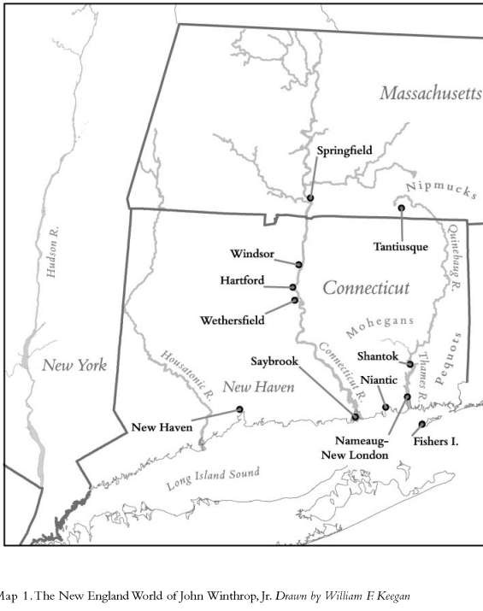
- Who fought on each side of the Pequot War?
________________________________________
________________________________________
________________________________________
________________________________________
________________________________________
________________________________________

- What was the Treaty of Hartford?
________________________________________
________________________________________
________________________________________
________________________________________
________________________________________
________________________________________

- What were two specific stipulations in the Treaty of Hartford?
_____________________________________________________________________________________
_____________________________________________________________________________________
_____________________________________________________________________________________

- What was one possible cause of the Pequot War?
_____________________________________________________________________________________
_____________________________________________________________________________________
_____________________________________________________________________________________

Name: __________________________________________________________ Date: ___________________________________
Classwork
Close Reading, Day 2: Treaty of Hartford
Focus:

The Impact of The Treaty of Hartford
Directions: Complete the chart below by summarizing the direct impact of the Treaty of Hartford on each group using your notes from the past few days.

 | How did the Pequot War and Treaty of Hartford impact this group? | What might be the long-term impacts of the Treaty of Hartford for this group?
The Pequot
The English Colonists
The Narragansett and Mohegans

Additional Evidence
Directions: Read and annotate the following secondary source excerpt that discusses the aftermath of the Pequot War and the signing of the Treaty of Hartford. After reading the excerpt, add key evidence from the text to your chart on page 2.

Source: Walter W. Woodward, “Which Man’s Land? Conflict and Competition in Pequot Country”, 2010.

1 At the end of the Pequot War in 1637, all parties to the victory hungered for the spoils of war. These included not only the former Pequot lands—an extensive region along the Long Island Sound extending up the western bank of the Pequot (now Thames) River watershed to the palisaded Mohegan settlement at Shantok (see Map 1)—but control over the surviving Pequots as well.

2 While Pequot warriors known to have fought against the English were executed (bounties were paid to Indian allies for bringing English authorities Pequot warriors' heads and hands), noncombatants were distributed among the victors as servants or tributaries. Connecticut and Massachusetts leaders took as many as three hundred Pequots as servants into their households, but what these expansion-minded colonies wanted most was access to and control of the former Pequot lands.

3 The Mohegans and Narragansetts, who had allied with the English, were also interested in the former Pequot lands, particularly in the hunting rights to them, but were even more interested in the human spoils. The Narragansetts had suffered from a severe epidemic of smallpox in 1633 and saw absorbing former Pequot members into their tribe as an opportunity to offset some of their recent population decline. For the Mohegan Uncas, who had been a sachem of relatively limited power before the war, subjugating and exacting tribute from the former Pequots was part of an aggressive plan to increase Mohegan authority within the region. Some surviving Pequots, too—despite a declaration by Connecticut in the 1638 Treaty of Hartford that their existence as a tribe should be eradicated in both name and in fact—sought vigorously to retain a hand in their own destiny.

4 An untold number of former Pequot warriors who had avoided capture were quietly welcomed into the villages of their former Indian opponents (in which they often had relatives); other Pequot survivors sought to stay together in remote places under the protection of their own sachems. Michael Leroy Oberg has described the result of this confused mix of postwar agendas and survival strategies: "'Mohegan' and 'Narragansett' villagers were not always what they seemed. Indians who had been Pequots could be Mohegans, Narragansetts, or Niantics while remaining Pequots."

Author’s Claim:

Everybody Writes
Directions: Answer each of the everybody writes questions in complete sentences.

- Who seemed to benefit the most from the Treaty of Hartford? Why?
________________________________________________________________________________________________________________________________________________________________________________________________________________________________________________________________________________________________________________________________________________________________________________________________________________________________________________________________________________________________________________________________________________________________________________________________________________________________________________________________________________________________________

- What seemed to be the intended purpose of the Treaty of Hartford? Was the goal really to secure peace?
________________________________________________________________________________________________________________________________________________________________________________________________________________________________________________________________________________________________________________________________________________________________________________________________________________________________________________________________________________________________________________________________________________________________________________________________________________________________________________________________________________________________________

Notes from Class Discussion:

Name: _________________________________ Date: ___________________________
Exit Ticket
Treaty of Hartford: Impact of the Pequot War
Directions: Answer the following question in a complete paragraph using at least two specific pieces of textual evidence.
Prompt: How did the Pequot War impact the Pequot people?

________________________________________________________________________________________________________________________________________________________________________________________________________________________________________________________________________________________________________________________________________________________________________________________________________________________________________________________________________________________________________________________________________________________________________________________________________________________________________________________________________________________________________
________________________________________________________________________________________________________________________________________________________________________________________________________________________________________________________________________________________________________________________________________________________________________________________________________________________________________________________________________________________________________________________________________________________________________________________________________________________________________________________________________________________________________________________________________________________________________________________________________________________________________________________________________________________________________________________________________________________________________________________________________________________________________________________________________________________________________________________________________________________________________________________________________________________________________________________________________________________________________________________________________________________________________________________________________________
____________________________________________________________________________________________________________________________________________________________________________________________________________________________________________________________________________________________________________________________________________________

Name: _________________________________ Date: ___________________________
Homework

